Lab2 FLCD
Link to github:
Statement: Implement the Symbol Table (ST) as the specified data structure, with the corresponding operations
Deliverables: class ST(source code) + documentation.
Solution: HashTable using a list of deques

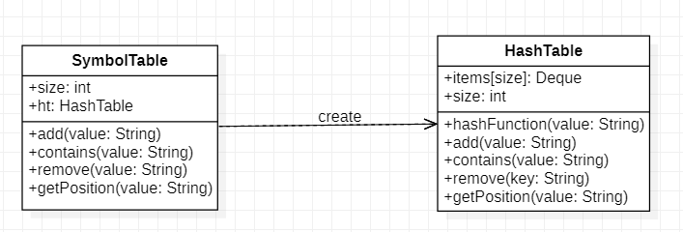
add(value)
*pre*
input: value of type String
*post*
output: add the value to my list based on my hashFunction

contains(value)
*pre*
input: value of type String
*post*
output: verify if exists

remove(key)
*pre*
input: key of type String
*post*
output: remove the value from list based on my hashFunction

hashFunction(value)
*pre*
input: value of type String
*post*
output: hash code for the given value
getPosition(value)
*pre*
input: value of type String
*post*
output: position in list, position in deque

